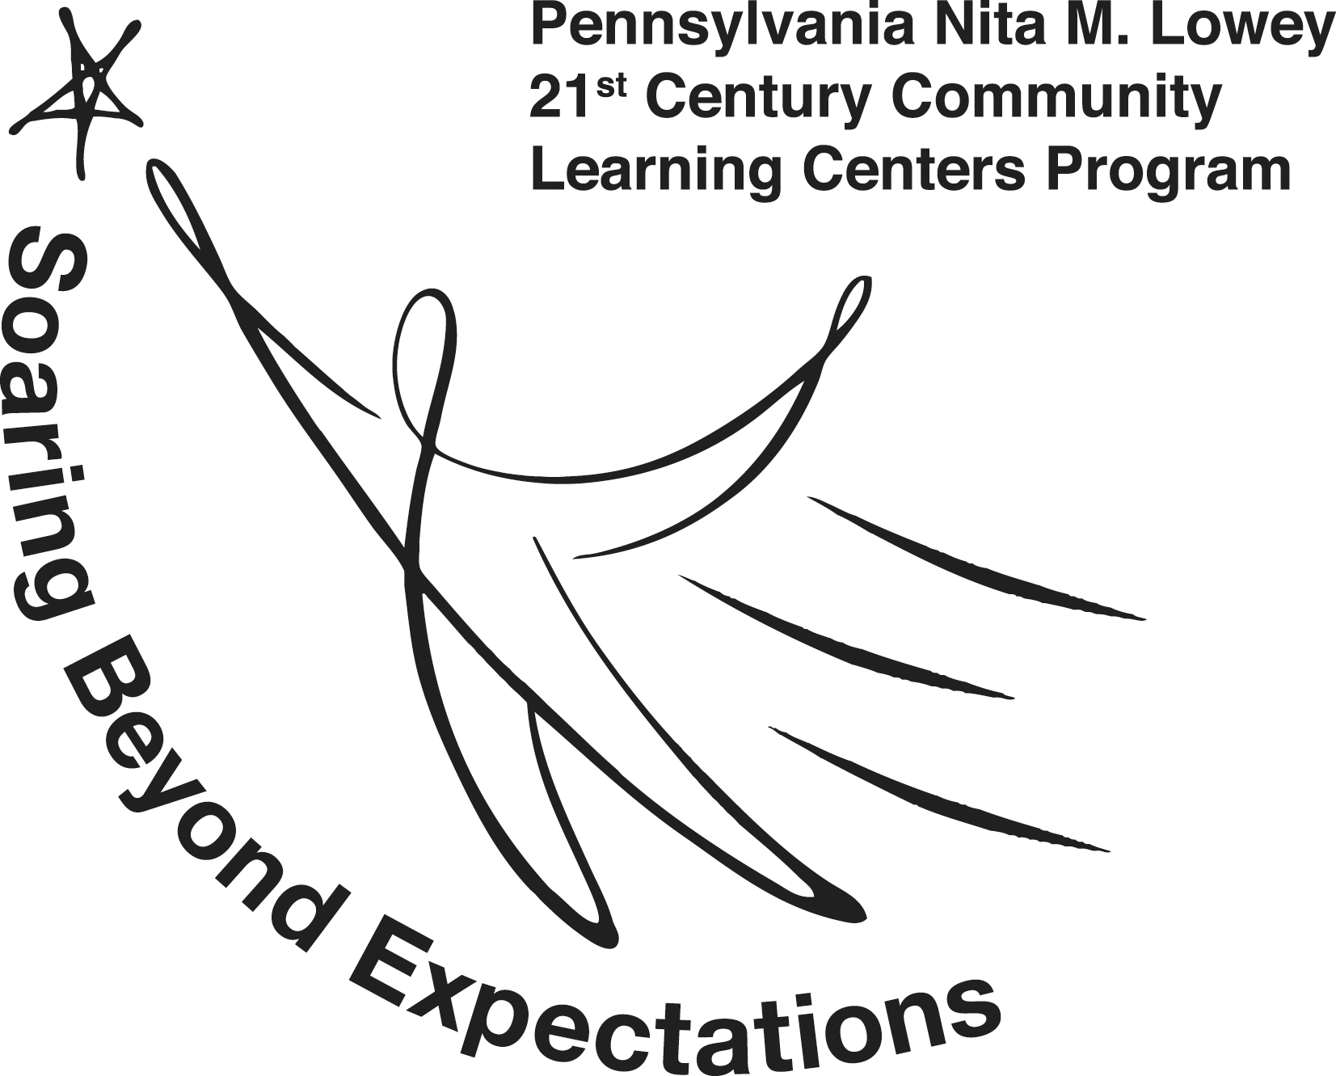

Sample 21st CCLC Data Sharing Agreement
THIS DATA SHARING AGREEMENT is entered into as of (the "Effective Date") between [School/LEA Name], with a place of business at [School/LEA Address], and [Grantee Name], with a place of business at [Grantee Address]. [Grantee Name] shall include all officers and employees of [Grantee Name]. The purpose of this agreement is to authorize the release of student personal identifiable (PII) and education information by [ LEA/School] to [Grantee Name] and clarify the use of data.
WHEREAS:
- [Grantee Name] is a recipient of a 21st Century Community Learning Centers grant and is contractually obligated to report student data as determined by the Performance Results Act (GPRA) measures and the state 21st Century Community Learning Centers evaluation plan. Data must be collected for all students who attend the program, including those at [School/LEA Name].

- [Grantee Name] is an authorized representative of [School/LEA Name] and may receive a data extract to comply with federal GPRA data collection standards and state evaluation.

- The fields being requested include persons who are aged 21 and younger.

- The fields being requested include:
Data Element | Rationale
PASecure ID | Required for state reporting
Last Name (or initial) | Helps ensure an accurate match
First Name (or initial) | Helps ensure an accurate match
Grade Level | Required for federal and state reporting
Educating School Building | Allows for school-level analysis
PSSA/PASA scores (prior year and current year) | Required for GPRA Measure 1
GPA (prior year and current year) | Required for GPRA Measure 2
School attendance rate (prior year and current year) | Required for GPRA Measure 3
In-school suspensions (number and duration) – (prior year and current year) | Required for GPRA measure 4
Graduation/promotion/dropout status | Required for local evaluation report
Student demographics  - Race/ethnicity  - Economically disadvantaged  - Sex/gender  - Language  - Disability | Demographic descriptors – required for federal reporting and local evaluation report

- [Grantee Name] shall obtain and keep on record written parental consent to access the above-identified data from [School/LEA Name] for participating students,

- [Grantee Name] shall maintain multiple data security measures and protocols consistent with FERPA to ensure the protection, security, and confidentiality of data shared under this agreement.

- [Grantee Name] may only use the data for the authorized purposes for which it is provided.

- Data are reported federally in the aggregate. Some de-identified, student-level data will be shared with the Allegheny Intermediate Unit (AIU) – Department of Evaluation, Grants, and Data (EGD), with a place of business at 475 E Waterfront Drive, Homestead, PA 15120. The AIU is the contracted state evaluator of the 21st Century program. Data must be shared with this entity for statewide reporting and evaluation. All data shared with the AIU will only be accessed within the EGD department, which has the necessary data safety protocols, staff clearances, and the Pennsylvania Department of Education data sharing agreement in place to access this data.

- Within [Grantee Name], data from [School/LEA Name] are only made available to staff directly responsible for the 21st Century Community Learning Center's evaluation and data management.

- De-identified student-level data will also be shared with [Grantee Name]’s contracted local evaluator [Name], who has a place of business at [address]. 21st-century grantees are obligated to undergo a local evaluation and submit an annual local evaluation report to the Pennsylvania Department of Education for grant compliance. All data in this evaluation are reported in the aggregate.

- The term of this agreement shall be 12 months from the Effective Date above and will be renewed annually upon completion of a newly signed data-sharing agreement.
- [School/LEA Name] agrees to provide [Grantee Name] with a data extract by [Enter Date] so that [Grantee Name] can remain in compliance with state and federal reporting deadlines.

- [Grantee Name] shall destroy any PII from education records within 30 days from when it is no longer needed for any compliance with the Federal program activities and responsibilities.
EXECUTION
[GRANTEE NAME] [LEA/SCHOOL NAME]
BY: _________________________________ BY: ________________________________
[Name], [Title] – [Department, if applicable] [Name], [Title] – [Department, if applicable]
Authorized Representative Authorized Representative
DATE: ______________________________ DATE: ______________________________

