Finding Reference Points with the Model Car Demonstrator

Model Car Demonstrator Exercise
Supplies: Model car demonstrator; yardstick or the edge of a desk.
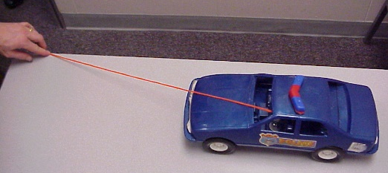
Instructions:
This can be demonstrated for the whole class or divide the class into groups and provide a model car for each group.
- Place the model car demonstrator next to a straight edge to represent a curb.
⇨ Use the yardstick or edge of a table or desk as the curb
- Extend the string in a straight line until it just makes contact with the hood of the car. Vision doesn’t bend, neither should the string.
⇨ The string represents the driver’s line of vision
- The point on the surface where the string is being held is the point where the driver is first able to see the surface.
- When the string is to the edge of the curb, the string will show where the driver would see the curb in relation to the car. The car below demonstrates a reference point for a vehicle 3 feet from a curb line. The string (the driver’s point of view) appears to the driver to be running from the edge of the table (curb line) through the center of the hood.

For students having trouble with reference points have them practice with this exercise until they are more familiar with reference points.
This can be used for all reference point lessons by simply moving the car various distance from the straight edge.

