Pennsylvania Migrant Education Program

Diploma Project Toolkit

A Guide for Pennsylvania Parents: Road to College and Career
October 2018 (Revised)

COMMONWEALTH OF PENNSYLVANIA
DEPARTMENT OF EDUCATION
Forum Building, 607 South Drive
Harrisburg, PA 17120
www.education.pa.gov
Commonwealth of Pennsylvania
Joshua Shapiro, Governor
Department of Education
Dr. Khalid N. Mumin, Secretary
Office of Elementary/Secondary Education
Dr. Carrie Rowe, Deputy Secretary
Bureau of School Support
Amy Lena, Director
Division of Student Services
Carmen Medina, Chief
The Pennsylvania Department of Education (PDE) does not discriminate in its educational programs, activities, or employment practices, based on race, color, national origin, [sex] gender, sexual orientation, disability, age, religion, ancestry, union membership, gender identity or expression, AIDS or HIV status, or any other legally protected category. Announcement of this policy is in accordance with State Law including the Pennsylvania Human Relations Act and with Federal law, including Title VI and Title VII of the Civil Rights Act of 1964, Title IX of the Education Amendments of 1972, Section 504 of the Rehabilitation Act of 1973, the Age Discrimination in Employment Act of 1967, and the Americans with Disabilities Act of 1990.
The following persons have been designated to handle inquiries regarding the Pennsylvania Department of Education’s nondiscrimination policies:
For Inquiries Concerning Nondiscrimination in Employment:
Pennsylvania Department of Education
Equal Employment Opportunity Representative
Bureau of Human Resources
Voice Telephone: (717) 783-5446
For Inquiries Concerning Nondiscrimination in All Other Pennsylvania Department of Education Programs and Activities:
Pennsylvania Department of Education
School Services Unit Director
Forum Building, 607 South Drive, Harrisburg, PA 17120
Voice Telephone: (717) 783-3750, Fax: (717) 783-6802
If you have any questions about this publication or for additional copies, contact:
Pennsylvania Department of Education
Division of Student Services
Forum Building, 607 South Drive, Harrisburg, PA 17120
Voice: (717) 783-6466, Fax: (717) 783-6642
www.education.pa.gov
All Media Requests/Inquiries: Contact the Office of Press & Communications at (717) 783-9802.

Table of Contents
Parent Unit – Road to College and Career 1
Goal Setting 1
Parent-Student Plan 3
Self-Assessment for Parents 4
Support Team 5
High School Credits 8
Tests and Test-Taking Strategies 10
Planning for Postsecondary Education 12
Postsecondary Programs 13
Keywords 13
Preparing for Post-Secondary Education 14
Paying for Postsecondary Education 16
Notes and Additional Resources 20

Disclaimer: The Migrant Education Program (MEP) is authorized by Title I, Part C of the Elementary and Secondary Education Act (ESEA) of 1965, as amended. This tool and all its components were developed with funding from the U.S. Department of Education (ED), Office of Migrant Education (OME). The opinion expressed herein do not necessarily represent the positions or policies of the U.S. Department of Education, and no official endorsement by the U.S. Department of Education should be inferred. You are hereby notified that any dissemination, distribution, alteration, or copying of this tool or its components is strictly prohibited without prior approval from the Pennsylvania Department of Education, specifically the Pennsylvania Migrant Education Program.

Parent Unit – Road to College and Career

Unit at a Glance
This is a standalone unit for parents and guardians. It incorporates elements from each of the units for students. Format is parent-friendly and to the point. Material should be able to be covered in two or more workshops.

Highlights
- Goal setting and parent-student plan
- Support team
- High school credits
- Test taking strategies
- Postsecondary planning checklist

How can I be helpful?
Think back on strengths, talents, and interests you have always seen in your child and suggest he or she include them in building a career profile.
Make a list of three or four friends, colleagues, family members, or members of the community who could talk with your child about career choices.
Ask your child about extracurricular activities that could help him or her develop a talent, skill, or interest.
Encourage your child to stay in school.
Listen, listen, listen!
Help your child work through a process rather than arguing against ideas with which you disagree.
You know best what motivates your child—a smile, a joke, a hug—if he or she gets frustrated or overwhelmed.
Celebrate all steps in the right direction—even the tiny ones!

Goal Setting

How can I support my child’s choice of career?
As the people who know the child best, parents and guardians are in a unique and valuable position to give feedback and insights. Most parents and guardians have concerns about their child’s choice of career path, even if they are excited that their child is discovering what he or she would like to do in life. To that effect, you should set goals for your child.

Goal Setting
- Make goal-setting as engaging as possible – We all want what’s best for our children. Teach your child to think in terms of setting and accomplishing goals. This will help them become their own best source of fulfillment. This will empower them to control the outcomes in their lives and give them the recognition they deserve.
- Set short-term and long-term goals – Setting goals can be a double-edged sword. Short-term and long-term goals should be simple, realistic, and achievable. Work with your child to divide long-term goals into achievable steps. For example:
  - The long-term goal of improving their English would have short-term goals such as, learn three new words and their concept each week. This will help build their academic vocabulary.
- Identify strengths and weaknesses – The sense of gratification your child gets from accomplishing small, yet meaningful goals will help sustain the energy and belief as they move towards greater accomplishments. Help them learn the benefits of keeping goals small, manageable, and short-term.
- Identify available resources in the school and community – Think about available resources when your child first communicates frustrations, disappointments, and helplessness in school.
- What can I do as a parent to help my child graduate from high school?
- Who can help me?
- Am I aware of the high school graduation requirements?
- What are my challenges that prevent me from helping my child?

****Feel free to ask for assistance from your Student Support Specialist when planning goals.

Parent-Student Plan
The chart below explores school goals, your child’s goals, and your goals as a parent. After listing the goal(s), create a plan to achieve it, indicate whether it is long-or short-term, and set a target date. This should be a good conversation starter between you and your child.
Goals | Plan to achieve my goal (i.e. needed courses or activities) | Long-or  short-term? | Target Date
School
Student
Parent

What are my concerns?
Can my child succeed at this career?
Does my child have the skills and knowledge required for this kind of work?
Will my child stick with their decision?
Can my child support him/herself by doing this kind of work?
Will this career path require my child to leave our community to study and work?
What are the long-term prospects for this occupation?
Parent Tip
Communication is a “two-way street.”
Students can bring valuable information from school and from mentors!
Parents, including those who have not been to high school or college, can give good advice!

Self-Assessment for Parents
As parents, you play a critical role in your child’s “planning team.” Begin by establishing a positive, supportive role to assure that your child has everything needed to finish high school. Work with your child and with the school to identify the steps that will lead to a satisfying occupation or college education beyond high school graduation. Use this checklist to determine how you are doing in these areas:

Strengths
☐ I trust that my child is capable of doing excellent work in their courses.
☐ I work as a team with my child, and I participate in the process of gathering the information that my child needs.
☐ I am willing to serve as an example of hard work, self-reliance, and tenacity for my child.
☐ I talk with my child often about their plans for the future, and I listen to their ideas and plans.

Challenges
☐ I am busy at work and do not always have time for a conversation with my child.
☐ My child is the first in our family to have a goal to go to college.
☐ I sometimes hesitate or do not know where to get help.
☐ I am not sure which courses my child needs to take to graduate from high school.
☐ I know my child’s interests and preferences.
☐ I know my child’s college/career plans after high school.

Planning Ahead
☐ I am prepared to make some economic sacrifices to help my child succeed in school.
☐ I have/will identify sources of funding for my child’s postsecondary education and have a savings plan.
☐ I work to coordinate our family’s schedule in support of my child’s academic schedule.
☐ I can help my child guidance on getting or keeping a job.
☐ I support my child’s career interests and goals.
☐ I am aware and prepared to support my child’s transportation and living arrangements after high school.

“The Planning Team”

Support Team

The importance of forming a support team for parents
It is very important for migrant parents to know and support their children’s future by reaching out to the local community agencies, libraries, recreation centers, and faith-based organizations that they are participating in. They could provide the academic support or recreational activities. These are the important keys to academic success. The parents and teachers or support person roles are not to replace, but rather to support and reinforce each other’s roles to ensure the child’s achievement. Parents need to take action by attending and supporting all activities that their children participate in to help their children succeed in the short-term and long-term goals. Parents, teachers, and advocates need to build up a partnership to create an ongoing mutual effort toward a shared goal: seeing their children succeed.

The Support Team for Parents
Languages  Support | School | Local Community Agencies | Libraries | Recreation Centers | Faith-based Organizations | Family Members
All schools should have language support line. | Get to know your children teachers, counselor, dean of students, and support staff. | What is offering in the community? | What kind of educational activities or workshops do they offer? | What kind of sports or recreational activities do they offer? | What kind of services do they provide to help my children? | I can count on this family member to help motivate my children through their education stages.
Who is the right person for this support?

Support Team for Parents
Language Support: Phone: Language:
By law, the school district must provide support to speakers of other languages. Parents need access to interpreters to participate in any school meeting or activity. This includes meeting with teachers, counselors, dean of students, and the school supports.
School | Local Community Agencies | Libraries, Recreation Centers, Faith-Based Org | Other Support Networks or Mentors
Teachers  Name:  Phone:  Email: | Coordinators  Name:  Phone:  Email: | Librarians  Name:  Phone:  Email: | Name:  Phone:  Email:
Counselor  Name:  Phone:  Email: | Case Workers  Name:  Phone:  Email: | Program Leaders  Name:  Phone:  Email: | Name:  Phone:  Email:
Principal/Dean of Students  Name:  Phone:  Email: | Team Leaders  Name:  Phone:  Email: | When does the program start? | Name:  Phone:  Email:
Migrant Staff
Name:
Phone:
Email:

In the U.S., parents meet with teachers, school counselors, and other support staff (such as PA-MEP staff) to discuss their child’s future.
Keep the name and contact information for your child’s school counselor, a trusted teacher, PA-MEP staff, and your child’s mentor in a handy place and contact them when you need advice and support.
In the U.S., children can respectfully disagree with their parents. If you and your child are unable to resolve an issue, consult a school counselor, trusted teacher, or the child’s mentor for solutions.
Remember to contact your “planning team” to celebrate successes, too!

High School Credits
Every school has different graduation requirements. Below is an example of a typical high school in Pennsylvania. Your child’s list of course requirements will look similar to this but be sure to find out the school’s exact requirements, so your child can meet all requirements completely and on time. If you do not have easy access to this information through your school’s website, make an appointment with the school counselor. The counselor is the best person to ask for this information.
Course | Grade 9 | Grade 10 | Grade 11 | Grade 12 | Credits
English | 1 | 1 | 1 | 1 | 4
Mathematics | 1 | 1 | 1 | 1 | 4
Science | 1 | 1 | 1 | 1 | 4
Social Science | 1 | 1 | 1 | 1 | 4
Foreign Language |  |  | 1 | 1 | 2
Humanities | 1 | 1 |  |  | 2
Electives |  |  | 1 | 1 | 2
Health and Physical Education | .5 | .5 | .5 |  | 1.5
Other Graduation Requirements: Graduation Project, Service Hours and Keystone Exams |  |  |  | Total | 23.5

Please fill out the chart below with your child’s school district requirements:
Course | Grade 9 | Grade 10 | Grade 11 | Grade 12 | Credits
English
Mathematics
Science
Social Science
Foreign Language
Humanities
Electives
Health and Physical Education
Other Graduation Requirements: Graduation Project, Service Hours and Keystone Exams |  |  |  | Total

If your child is having trouble with credits, there are resources in the community, school, state, and federal programs and of course the Pennsylvania Migrant Education Program. Talk to the Migrant Student Support Specialist about where to find these resources in your community.

Did You Know?
In Pennsylvania, children have the right to receive a free public education until they are 21 years old - regardless of immigration status, health, or cognitive or physical abilities.

Tests and Test-Taking Strategies
The charts on the following page list the tests given for postsecondary/career purposes and state mandated tests, such as the Keystone exams:

11th & 12th Grade Voluntary Placement Tests
TESTS | PSAT  Preliminary Scholastic Assessment Test | SAT  Scholastic Assessment Test | ACT  American College Test | TOFEL  Test Of English as a Foreign Language | ASVAB  Armed Service Vocational Aptitude Battery
Grades | 11th | 11th & 12th | 11th & 12th | 12th | 12th
Test Cost | $16 | $45 No essay  $60 Essay | $62 | $195 | No Cost
Test Dates | Winter  Spring  Summer | Fall  Winter  Spring  Summer | Winter  Spring  Summer | Winter  Spring | To be determined by Military Recruiter
Test Content | Math  Critical Reading Writing | Reading  Writing  Math | English  Math  Reading  Science | Speaking  Writing  Reading Listening | Math  Science  Reading Electronics Mechanical
Test Purpose | Provides preparation for the SAT and used to qualify students for the National Merit Scholarship Competition | Measures readiness for college | Measures readiness for college | Assessment of language skills | To determine job classification / placement in the military

School Mandated Assessments
TESTS | PSSAs  PA State Standard Assessments | KEYSTONE | WIDA ACCESS Test
Grades | 3 - 8 | 11 | K-12
Test Cost | No cost | No Cost | No Cost
Test Dates | April | December, January, May | Winter
Test Content | Math  English Language Arts Science | Literature Biology Algebra 1 | Listening Speaking Reading Writing
Test Purpose | Measure student achievement across state levels | End-of-course assessment designed to address proficiency | To determine ESL Placement
Next is a calendar template you can use to record your child’s test dates.

Write down what you will do with your child to make sure they are successful in their tests.
Before the Test:

After the Test:

Planning for Postsecondary Education
This section emphasizes the steps that parents will need to take in order to prepare for postsecondary education. These discussions and preparations should begin early and involve as many supportive educators, mentors, family members, and peers as possible.
What types of postsecondary school /program matches my child’s talents and interests?
- Parents should start conversations with their children about postsecondary options as early as 8th or 9th grade.
- Every college, trade school, and university in the U.S. has it’s own entrance requirements. Parents can find this information online or through the school counselor or Migrant Support Staff.
- Parents should support their children in getting involved in the college preparedness programs available in each school district.

Postsecondary Programs
College Type | What You Can Earn | Career Examples | Characteristics
Apprenticeship / On-the-Job Training | - Nationally-recognized credential from the U.S. Department of Labor  - Paid Work  - Debt-Free College Credit  - Workplace-relevant knowledge and skills | - Software Developer  - Pharmacy Technician  - Mechanic  - Certified Nursing Assistant  - Construction Craft Laborer  - Electrician  - Welder | - Working from day one  - Incremental wage increases  - Competitive wages over a lifetime
Trade / Technical School | - Certificate  - Diploma  - Associate’s degree | - Computer Programmer  - Cosmetologist  - Dental Assistant  - Mechanic  - Medical Assistant  - Plumber | - Smaller class sizes  - Evening and weekend classes offered  - Focus on skills necessary for a specific career
Community College | - Certificate  - Diploma  - Associate’s degree  - The ability to transfer to a 4-year college or university | - Accountant  - Airplane Mechanic  - Legal Assistant  - Paramedic  - Dental Hygienist  - Restaurant Manager | - Smaller class sizes  - Evening and weekend classes offered  - Can often transfer to a 4- year college or university  - Often smaller schools found in communities
4-year College or University | - Bachelor’s degree  - Master’s degree  - Doctorate degree  - Professional degrees | - Engineer  - Graphic Designer  - Pharmacist  - Pilot  - Social worker  - Teacher | - Most people attend full-time  - Can take many different classes  - Usually have dorms on campus

Keywords
Associate’s degree: A type of degree awarded to students at a U.S. Community college, usually after two years of study.
Bachelor’s degree: A degree awarded to undergraduates, usually after four years of study at college.
Career: The occupation for which you or your child is trained.
College: Any education after high school that earns your child a degree.
Community College: Colleges that provide the first two years of a four-year college education or prepare students for certain jobs.
Degree: What your child earns when he or she graduates from college, like an associate or bachelor’s degree.
Technical College: Colleges that offer employment courses and programs, which teach specific knowledge and skills leading to certain jobs.
University: A type of school that offers a degree and a wide variety of majors. Application fee waivers are available for students who need it, through school counselors.
Five key elements for a good essay that parents need to know
- Getting involved in community and school activities will provide experiences that will facilitate the essay writing process.
- Not having an essay could delay the application process.
- Have a teacher review your child’s essay before submission.
- Support your child in the essay writing process and have a comfortable adequate environment.
- Follow up with your child’s progress and ask them about additional ways you can support them.

Preparing for Post-Secondary Education

Parent Checklist

9th Grade
Schedule a meeting with your child’s school counselor to make sure your child is on track to assure is enrolled in classes that fulfill graduation requirements and will prepare your child for postsecondary education, the military, or a career.
☐ Ask your child’s counselor if the high school offers vocational options for 10th grade, if interested.
☐ Discuss with your child a possible plan to save money for college, if you have not done already.
☐ Talk to your child about career interests (Onet.org/miproximopaso.org) – pacareers.org
☐ Encourage your child to get involved in extracurricular activities that support their interest and build life skills such as leadership, self-reliance, creativity, teamwork, decision-making, and financial literacy.

10th Grade
☐ Learn the basics about costs, saving, and financial aid.
☐ Meet with your child’s school counselor to make sure they are on track for graduation.
☐ Conduct research via internet or public library to find information on college/technical school programs, tuition, and costs, and scholarships.
☐ Remind your child to continue taking classes that fulfill graduation requirements and build skills.
☐ Continue to encourage your child to get involved in extracurricular or volunteer activities.
☐ Motivate your child to visit college/technical schools and participate in summer college prep programs, if available.

11th Grade
☐ Follow up with your child’s school counselor to make sure your child is on track for graduation.
☐ Remind your child to enroll in courses required for high school graduation and/or career of interest.
☐ Remind your child to sign up to take the PSAT in the fall if needed (If unsure talk to your counselor.)
☐ Make a list of colleges/technical schools and programs that interest your child.
☐ Research and narrow down possible colleges/technical schools and majors and careers with your child.
☐ Remind your child to register for the SAT and/or ACT in the spring.
☐ Remind your child to prepare for the SAT or ACT. Talk about its importance (how the result can impact them in getting into college and for scholarships).
☐ Motivate your child to continue exploring and making decisions about majors and careers.
☐ Continue encouraging your child to visit colleges /technical schools throughout the year. Become aware of college trips that your child’s school may offer.
☐ Make a list of at least five colleges/technical schools that offer the course of study your child is interested in.
☐ Remind your child to prepare for SAT if they are thinking about taking it in their senior year, if needed.
☐ Continue informing yourself about financial aid and talk to your child’s guidance counselor. Help your child search for scholarships that match your financial needs.
☐ Motivate your child to plan summer activities: volunteer, attend summer programs, or find a job or internship that matches their interests and builds valuable skills.
☐ During the summer take campus tours of schools of your child’s interests.

12th Grade
☐ Arrange a meeting with your child and their school counselor to make sure they are on track for graduation.
☐ Narrow down the list of colleges/technical schools your child is interested in.
☐ Remind your child to complete and submit all college applications.
☐ Remind your child to write application essays if needed and have it reviewed by a teacher.
☐ Remind your child to submit all necessary documents for financial aid assistance and/or available scholarships. (Submit FAFSA and PHEAA applications. First day the FAFSA is available is on October 1st, studentaid.ed.gov)
☐ Help your child to create a calendar that highlights important dates and deadlines.
☐ If letters of recommendation are required, remind your child to request them at least four weeks before the application deadline.
☐ Remind your child to register to take the SAT or ACT, if needed.
☐ Schedule a meeting with your child’s counselor to ensure that high school transcripts were submitted to colleges your child has applied to (November-March).
☐ Remind your child to make copies of all documents they send and have them follow up with school to make sure they have received information requested.
☐ Compare financial aid packages carefully. If you need help talk to your counselor or MEP staff.
☐ If you have not already, visit your child’s chosen college/trade school before accepting.
☐ Watch for your child’s acceptance or rejection letters, usually sent before May.
☐ Make sure that your child’s tuition and fees are paid.
☐ Finalize housing and meal plan for your child.
☐ Prepare your child for an exciting journey.

Paying for Postsecondary Education
As shown in the flowchart, there are two main types of financial aid: gift (grants and scholarships) and self-help (loans or work-study). Your child may need both. They may need your financial support depending on the aid they receive. The terms are explained after the flowchart.
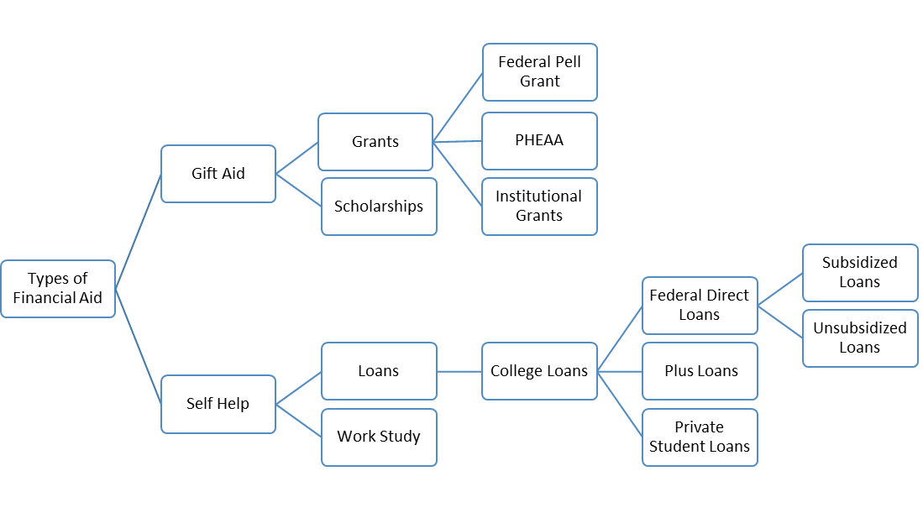

Keywords
Federal Direct Loans: A program that provides low-interest loans to postsecondary students and their parents.
Federal Pell Grant: Subsidy the U.S federal government provides for students who are in need to pay for college.
Financial Aid: Financial aid from the federal government to help you pay for education expenses at an eligible colleges or career school.
Grants: Financial aid, often based on financial need that does not need to be repaid.
Loans: Money college students or their parents borrow to help pay for college.
PHEAA: (The Pennsylvania Higher Education Assistance Agency) is based on financial need.
Plus Loans: Loans from private institutions are available to pay college expenses, based on your credit history.
Private Student Loans: Loans from private institution are available to pay college expenses, based on your credit history.
Scholarships: Money given to college student because of a special achievement, ability, or background.
Subsidized Loans: Based on financial need. The government subsidizes (pays) the interest on the loan while a student is in school and for a grace period of six months after graduation.
Unsubsidized Loans: Loans not based on financial need. The child will be charged interest from the time you borrow the money until the loan is paid off.
Work-Study: Jobs offered through a college and funded by the government to help students pay for college.
For details about the federal student aid programs, including maximum annual amounts and loan interest rates, visit Student Aid.
What are the benefits of your child continuing their education after high school?
Is your child thinking about leaving school to enter the workforce, so they can contribute to your family’s finances? This decision has serious consequences for your child’s future! Speak openly about your concerns with your child’s school counselor, trusted teacher, and PA-MEP staff. They will help you explore alternatives.
The chart (most recent available) shows that a more advanced education results in higher earnings. A student who graduates from high school will likely earn far more per week than a student without a high school diploma, especially over the course of his or her lifetime. This proves the point that the decision to leave high school to enter the workforce has serious consequences.
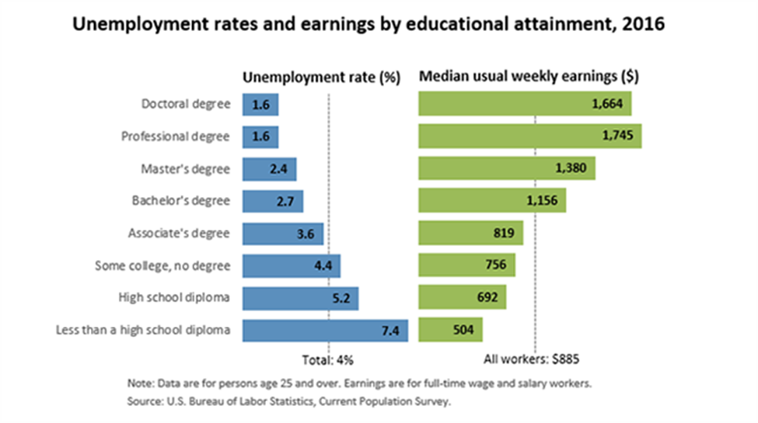

Pathways from High School to the Workforce
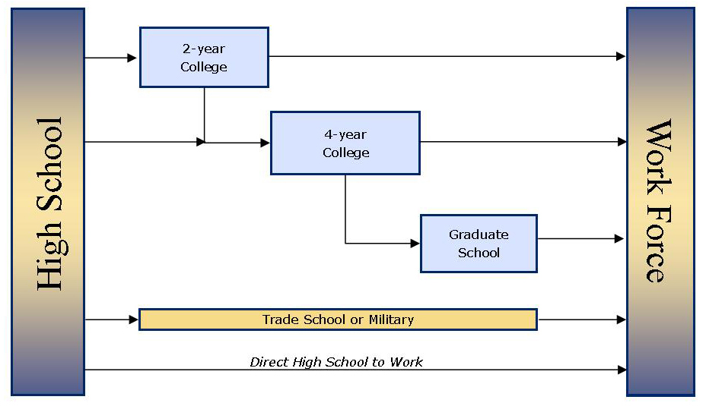
There are many ways for your child to get from high school to the workforce. It can be linear or take different steps along the way.

Free Application for Federal Student Aid (FAFSA)
The FAFSA is the standard application used to apply for financial aid from all federal programs. The application process is free and the form is available online. The FAFSA is your child’s key to receiving grants, work-study, loans, and even some scholarships.
Parents can also create a 529 College Savings Plan - Parents can start saving money through their employer or financial institution. A 529 plan is a tax-advantaged savings plan designed to encourage saving for future education costs. 529 plans, legally known as “qualified tuition plans,” are sponsored by states, state agencies, or educational institutions and are authorized by Section 529 of the Internal Revenue Code. You can use a 529 plan to pay for qualified higher education expenses at most colleges and universities, and many technical and career schools. The Pennsylvania 529 College Savings Program offers two savings plans. The PA 529 Guaranteed Savings Plan (GSP) is a lower-risk plan that helps your savings keep pace with rising higher education tuition. The PA 529 Investment Plan (IP) lets you choose from 16 investment options from The Vanguard Group. There are no income limits, and anyone can contribute. For more information go to PA 529.

Scholarships
Scholarships exist for every type of student seeking a college education. Some types of scholarships include: academic, athletic, for a particular ethnic group, women, and community service, among others. Additional things to make your scholarship application stand out are:
- Volunteer hours
- Enrolling in a school club
- Being active in school
- Being active in the community

Notes and Additional Resources

