Act 91 of 2021
Report on Classroom Monitor Permits

April 2023

COMMONWEALTH OF PENNSYLVANIA DEPARTMENT OF EDUCATION
333 Market Street
Harrisburg, PA 17126-0333 www.education.pa.gov

Commonwealth of Pennsylvania
Josh Shapiro, Governor

Department of Education
Dr. Khalid N. Mumin, Acting Secretary

Office of Postsecondary and Higher Education
Dr. Kate Shaw, Deputy Secretary

Bureau of School Leadership and Teacher Quality
Dr. Carissa Pokorny Golden, Director.

The Pennsylvania Department of Education (PDE) does not discriminate in its educational programs, activities, or employment practices, based on race, color, national origin, [sex] gender, sexual orientation, disability, age, religion, ancestry, union membership, gender identity or expression, AIDS or HIV status, or any other legally protected category. Announcement of this policy is in accordance with State Law including the Pennsylvania Human Relations Act and with Federal law, including Title VI and Title VII of the Civil Rights Act of 1964, Title IX of the Education Amendments of 1972, Section 504 of the Rehabilitation Act of 1973, the Age Discrimination in Employment Act of 1967, and the Americans with Disabilities Act of 1990.
The following persons have been designated to handle inquiries regarding the Pennsylvania Department of Education’s nondiscrimination policies:
For Inquiries Concerning Nondiscrimination in Employment:
Pennsylvania Department of Education
Equal Employment Opportunity Representative Bureau of Human Resources
Voice Telephone: (717) 783-5446

For Inquiries Concerning Nondiscrimination in All Other Pennsylvania Department of Education Programs and Activities:
Pennsylvania Department of Education
School Services Unit Director
333 Market Street, 5th Floor, Harrisburg, PA 17126-0333 Voice Telephone: (717) 783-3750, Fax: (717) 783-6802

If you have any questions about this publication or for additional copies, contact:
Pennsylvania Department of Education
Bureau of School Leadership and Teacher Quality
333 Market Street, 12th Floor
Harrisburg, PA 17126-0333
Voice: (717) 525 - 5833 Fax: (717) 783- 6736
www.education.pa.gov
All Media Requests/Inquiries: Contact the Office of Press & Communications at (717) 783-9802
Table of Contents

Introduction 4
Background 4
Issuance of Classroom Monitor Permits 5
Data Collection 6
Independent Evaluation 8
Conclusion 9
Appendix A: School Entities that Requested Classroom Monitor Permits During SY2021-22 and SY2022-23 (as of March 31, 2023) 10

Introduction
Act 91 of 2021 (Act 91) amended the School Code to address the substitute teacher shortage in commonwealth schools. Act 91 gave schools more flexibility when employing annuitants, day-to-day substitutes, educators with inactive certification, graduates of educator preparation programs, and a subset of those serving as student teachers to be employed as substitutes. The law also temporarily established a new permit for schools to hire classroom monitors and directed the Pennsylvania Department of Education to issue a report on the effectiveness of the Classroom Monitor Permit and recommendations for improvement or continuation of the permit after June 30, 2023.
In accordance with Act 91, this report explains how the Department implemented the Classroom Monitor Permit, provides data reported by school entities to the Department regarding the use and utility of the Permits, and includes the evaluation conducted by third-party evaluators from Grove City College and Cabrini University.

Background
The Classroom Monitor Permit is established in section 1218 of the School Code (24 P.S. §12-1218). The Classroom Monitor Permit (Type 9 Emergency Permit) allows individuals to deliver assignments preplanned by certified educators in schools; it does not allow those individuals to plan or create lessons or grade work or serve as substitute teachers. Rather, classroom monitors offer another way for schools to staff classrooms and provide future educators the field experience they need to be successful.
To qualify for a Classroom Monitor Permit, an individual must meet the following criteria:
- Be at least 25 years old;
- Have completed at least 60 semester hours or equivalent courses at an accredited college or university in this commonwealth, or have at least three years of school entity experience as a paraprofessional and be currently employed in a school;
- Meet background check and clearance requirements under the School Code and Child Protection Service Law; and
- Complete classroom management training developed by an intermediate unit and approved by the Department in accordance with 24 P.S. § 12-1218.
Intermediate units statewide developed and offered classroom management training for classroom monitors. The training included topics to prepare classroom monitors with basic classroom management skills along with other requirements, such as the need for some form of participant reflection ensuring the participants fulfilled the learning objectives and successfully completed the course. All training was approved by the Department. Intermediate units with approved training issued a certificate of completion to participants, as evidence of meeting the training requirement. Training and certificates are valid through June 30, 2023.

Issuance of Classroom Monitor Permits
Since the enactment of Act 91 in December 2021, the Department has issued a total of 884 Classroom Monitor Permits to 125 school entities. As seen in Table 1, there were 403 permits issued in 2021-2022 and an additional 481 permits issued in 2022-2023 (as of March 31, 2023). See Appendix A for the full list of school entities.
Table 1: Number of Classroom Monitor Permits Issued for School Years 2021-22 and 2022-23 (as of March 31, 2023)
 | 2021-2022 | 2022-2023  (as of 3/31/23) | Total
Number of Permits | 403 | 481 | 884
Permits were issued to school entities from 46 of 67 Pennsylvania counties. The figures below show the number of Classroom Monitor Permits issued in each county during school years (SY) 2021-22 and 2022-23.
Figure 1. Classroom Monitor Permits Requested During SY2021-22
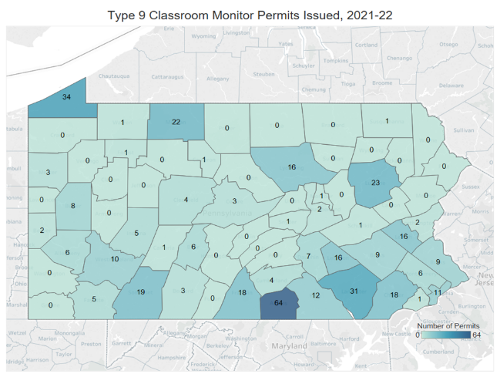

Figure 2: Classroom Monitor Permits Requested During SY2022-23 (as of March 31, 2023)
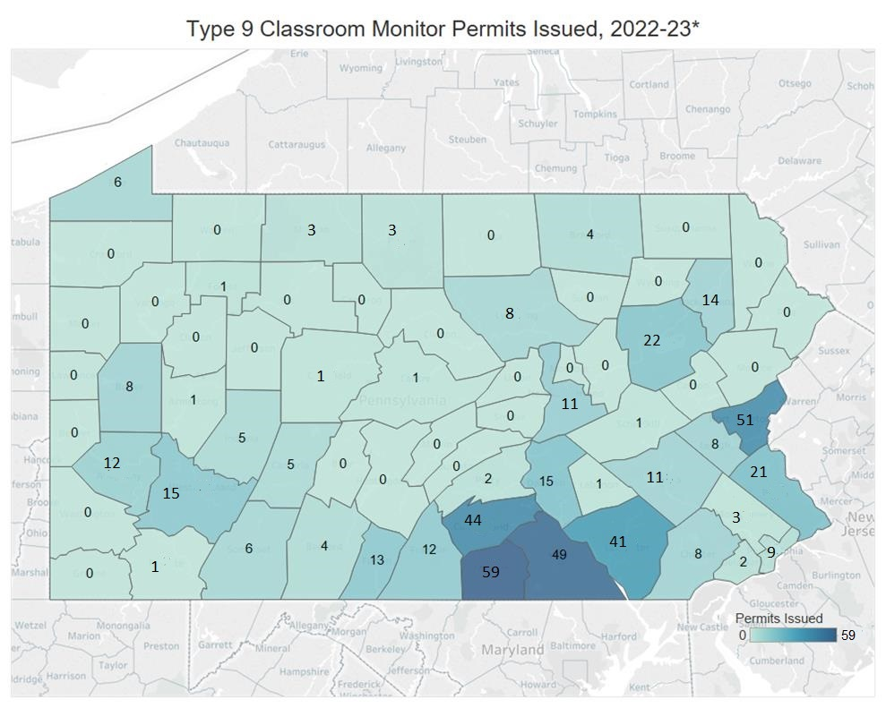

Data Collection
The Department developed a questionnaire and distributed it in February 2023 to obtain school entities’ input on the utility of the Classroom Monitor Permit and to collect the following information, as required by section 1218(e):
- The number of individuals who served as classroom monitors under this section and the number of days on which the school entity used the services of classroom monitors.
- The school entity's day-to-day substitute teacher compensation rates in the 2020-2021, 2021-2022 and 2022-2023 school years. For a school entity that uses a third-party entity to provide substitute teachers, the rate reported by the school entity is the take-home amount received by an individual.
The questionnaire was distributed to 778 school entities. Of the 629 entities (81 percent) that responded:
- 86 requested and used Classroom Monitor Permits (14 percent);
- 23 requested the permits but did not use them (3 percent); and
- 520 did not request the permits (83 percent).
Sixteen school entities that received Classroom Monitor Permits from the Department did not respond to the questionnaire.
Data collected from 629 questionnaire respondents showed that of the 86 school entities that requested and used Classroom Monitor Permits:
- 546 individuals served as classroom monitors during the 2021-22 and 2022-23 school years;
- Collectively, school entities used the services of classroom monitors for a total of 5,690 days. More than 60 percent of monitors were used from one to 15 days; and
- The average number of school days per school year that school entities used classroom monitors was 49.6 days, ranging from less than one day to 143.5 days in a school year.
Based on the questionnaire responses, in the 2020-2021, 2021-2022, and 2022-2023 school years, school entities that did not utilize the services of classroom monitors had a higher average day-to-day substitute pay rate than those who did utilize classroom monitors. The amount being paid for day-to-day substitutes rose each year from 2020-2021 to 2022-2023.
Table 2. Day-to-Day Substitute Teacher Compensation Rates
School Year | School Entities That Did Not Use Classroom Monitor Permits |  |  | School Entities That Used Classroom Monitor Permits
 | Average | Low | High | Average | Low | High
2020-2021 | $110.79 | $30.00 | $250.00 | $107.53 | $80.00 | $150.00
2021-2022 | $119.54 | $40.00 | $250.00 | $116.76 | $44.00 | $200.00
2022-2023 | $127.67 | $40.00 | $262.50 | $127.07 | $44.00 | $200.00

Overall, the majority of school entities recommended that Classroom Monitor Permits be allowed to continue past June 30, 2023.
Sixty-three percent of respondents (397) stated that the Classroom Monitor Permit should not be allowed to expire, while 37 percent (232) stated that it should be allowed to expire. Figure 3 shows responses overall and by whether the school entity issued Classroom Monitor Permits.

Figure 3: Responses Regarding Whether Classroom Monitor Permits Should Expire

Independent Evaluation
Act 91 required an evaluation of the permit and its effectiveness by an independent research organization which may include a college or university accredited by a regional accrediting agency. Accordingly, the Department partnered with evaluators from Grove City College and Cabrini University, both accredited by the Middle States Commission on Higher Education, to review the questionnaire data and provide recommendations for continuation of the Classroom Monitor Permit.
The evaluators’ findings are as follows:
- Classroom Monitor Permits provide an effective way to staff classrooms when certified substitutes are not available.
- The classroom monitor provision has existed for only a short time. However, given the number of permits issued rose 20 percent from SY2021-22 to SY2022-23 and the department received more than 375 responses in support of its continuance, the evidence strongly suggests that school entities would benefit from continuing to have the Classroom Monitor Permit as an option.
- The Department can improve use of the permits by providing stronger direction and oversight regarding how school entities obtain the Classroom Monitor Permit. This recommendation is based on the fact that 28 school entities replying to the questionnaire indicated that they are using classroom monitors, but the Department does not have a record of their permit applications.
- Data further indicates that most school entities that used the Classroom Monitor Permits did so for less than 15 days, with the majority using the permits for one to five days. One reviewer suggested the Department consider reducing the number of days that an individual can serve under a Classroom Monitor Permit to 20 days or less per school year.
- Finally, reviewers suggested that if the Classroom Monitor Permit is continued, the Department should collect more data to examine the permit’s effectiveness, as well as collect additional information to determine why school entities in certain counties are using Classroom Monitor Permits more than others.

Conclusion
Overall, analysis of the use of the Classroom Monitor Permit, as well as feedback from the field, strongly suggests that those holding Classroom Monitor Permits filled critical personnel gaps in school districts across the Commonwealth over the last two school years. While the permits are not designed to be a permanent solution to shortages in classroom personnel, evidence suggests the permits should continue while the Department works on longer-term solutions to the teacher shortage.

Appendix A: School Entities that Requested Classroom Monitor Permits During SY2021-22 and SY2022-23 (as of March 31, 2023)

- Antietam SD  - Appalachia IU 8  - Arts Academy CS  - Armstrong SD  - Bangor Area SD  - Beaver Valley IU 27  - Berks County IU 14  - Bellwood-Antis SD  - Berlin Brothersvalley SD  - BLaST IU 17  - Blue Ridge SD  - Bristol Township SD  - Boyertown Area SD  - Bradford Area SD  - Bucks County Technical High School  - Cameron County SD  - Capital Area IU 15  - Carlisle Area SD  - Central Dauphin SD  - Central Fulton SD  - Central Susquehanna IU 16  - Chester County IU 24  - Children of Joy Christian Academy  - Clairton City SD  - Colonial IU 20  - Conewago Valley SD  - Council Rock SD  - Cumberland Perry Area Career & Technical Center  - Cumberland Valley SD  - Dallas SD  - Danville Area SD  - Derry Area SD  - Donegal SD  - Dr Gertrude A Barber Center  - DuBois Area SD  - Duquesne City SD  - East Lycoming SD  - Eastern York SD  - Executive Education Academy CS  - Fairfield Area SD  - Ferndale Area SD  - Forbes Road SD  - Forest Area SD  - Galeton Area SD  - George Crothers Memorial School  - Gettysburg Area SD  - Greater Nanticoke Area SD  - Greenwood SD  - Hanover Public SD  - Harmony Area SD  - Hatboro-Horsham SD  - Hazleton Area SD  - Kane Area SD  - Karns City Area SD  - Kutztown Area SD  - Lakeview SD  - Lancaster-Lebanon IU 13  - Laurel Highlands SD  - Ligonier Valley SD  - Lincoln IU 12  - Lincoln Leadership Academy CS  - Luzerne IU 18  - Manheim Central SD | - Mariana Bracetti Academy CS  - Marion Center Area SD  - Memphis Street Academy CS @ JP Jones  - Midd-West SD  - Millersburg Area SD  - Millcreek Township SD  - Montessori Regional CS  - Northeast Bradford SD  - North Hills SD  - North Penn SD  - Northern Bedford County SD  - Northern Lebanon SD  - Northern York County SD  - Norwin SD  - Old Forge SD  - Oswayo Valley SD  - Otto-Eldred SD  - Pace School  - Palisades SD  - Palmyra Area SD  - Philadelphia City SD  - Philadelphia Hebrew Public CS  - Port Allegany SD  - Portage Area SD  - Premier Arts and Science CS  - Propel CS-Braddock Hills  - Propel CS-Homestead  - Propel CS-Northside  - Quakertown Community SD  - Rockwood Area SD  - Salisbury Township SD  - Salisbury-Elk Lick SD  - Seneca Highlands IU 9  - Seneca Valley SD  - Seven Generations CS  - Shade-Central City SD  - Shanksville-Stonycreek SD  - Shamokin Area SD  - South Eastern SD  - South Middleton SD  - South Western SD  - South Williamsport Area SD  - Southern York County SD  - Tidioute Community CS  - Tri-Valley SD  - Tuscarora SD  - Uniontown Area SD  - United SD  - Warrior Run SD  - Warwick SD  - Wattsburg Area SD  - Waynesboro Area SD  - West Branch Area SD  - West Phila. Achievement CES  - Westmoreland IU 7  - Wilkes-Barre Area SD  - Williamsburg Community SD  - Wilson Area SD  - Wissahickon CS  - Wyoming Area SD  - Young Scholars CS  - Young Scholars of Central PA CS

Act 91 of 2021 Guidance (pa.gov)
Sixteen school entities that issued permits did not respond to the Act 91 questionnaire and are not included in this number.
The average represents the pay for beginner substitutes (many school entities base pay on day ranges that vary).

