

Backing and Turning

# Backing – Left and Right

Supplies: Simulated steering wheel for each student; Pop cans; Model car; Small object to “back over”.

Instructions: Have students select a target that is to their rear and 90 degrees to the right Using the steering wheel, students demonstrate backing to the right. Repeat activity backing to the left.

**Evaluate performance for:**

* Correct steering control
* Visual search (correct shoulder)
* Checking swing of front end of car

BACKING

* Before backing, select a target to the rear at 90 degrees.
* Before backing, check for traffic, pedestrians, parked vehicles, and any stationary objects in front, around, and behind you.
* Keep both hands on the wheel, ready for hand-over-hand steering. Pull the wheel to the left to back left.
* Pull the wheel to the right to back right.
* The back of your vehicle will go in the direction you turn the wheel.
* Look back toward the direction you want the vehicle to go.
* Back slowly as you enter the turn.
* Make quick glances to the front and sides to be sure no one is near.
* Begin unwinding the steering wheel to finish the turn in a straight position

With the pop can, model car, and small object, demonstrate what can happen if not looking.

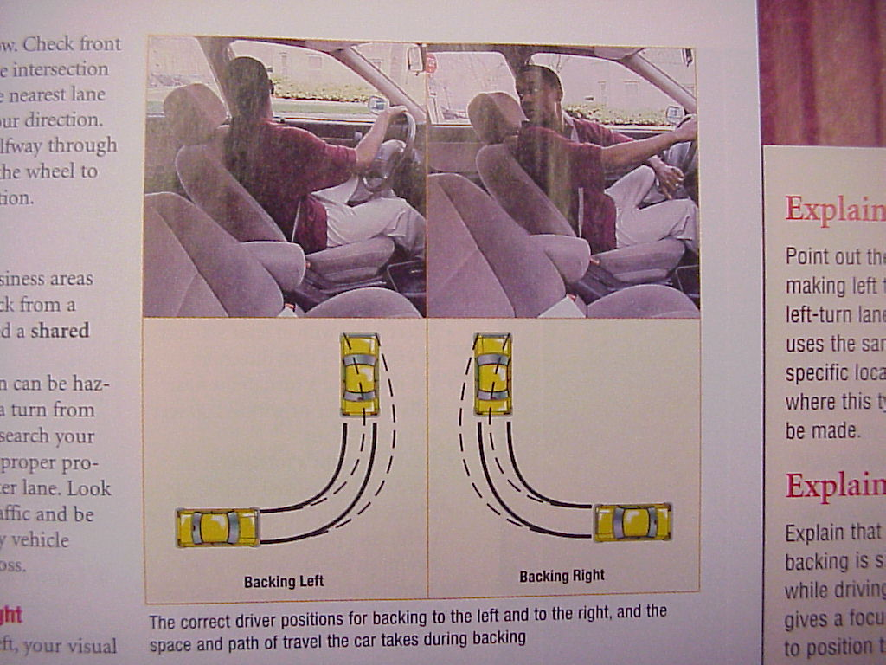

# Target Practice

Supplies: Simulated steering wheel, such as a paper plate – place a small strip of tape at the top of the wheel and ensure a piece goes over the top and to the back of the wheel; the beginning of the searching process, students visualize the space their vehicle will occupy.

A picture of the "steering wheel" created with a paper plate and a piece of tape.

Instructions: Give each student a simulated wheel.

* Hold the wheel at appropriate hand positions
* The teacher represents the target
* Instruct students to turn their head to look directly at you before moving the steering wheel to get you on target
* Move your position to the left and right side of the room. Instruct student to wait for your instruction to “get on target.” Ensure students turn their head to look directly at you, and then turn the wheel to get on target.
* Walk to the back of the room, instruct students to turn their head and steering wheel to keep you in alignment with the center of their steering wheel.

Watch for students who:

* Turn their wheel while turning their head, the head turns first to look for the target, then the wheel is turned to get on target.
* Check that students are turning the wheel, then centering back up by looking for the tape at the top of the wheel.

Note: When the students are on target, it will appear that their body is in alignment to the target.