Lane Position Targeting

Identify Advantages for Using Different Lane Positions
Supplies: Photos of parked car with door opening into traffic; busy intersection with traffic light; digital photo gallery.
Instructions:
Have students look at photos. Answer questions.
What are the advantages of having the car in lane position 2 before the car’s door is flung open?
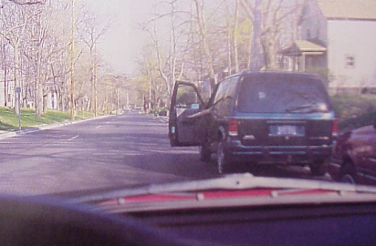
ANSWER: Room for the door without changing path of travel.
What actions should a driver take to be ready for the light to change?
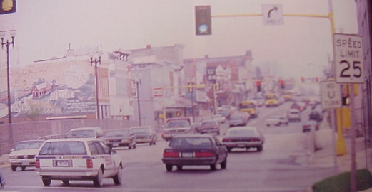
ANSWER: Cover the brake, turn head 45-degrees right to look for anything approaching from a line-of-sight restriction.

Targeting
Supplies: Simulated steering wheel; yard stick; crosses.

Instructions:
Part 1
Give each student a simulated steering wheel.
Part 2
Give the students a direction and speed they are traveling.
Watch the students’ head movements.
Watch the students’ turning movements.

Part 3
If student oversteers for the commands given, they “die”.
Give that student a cross and they are out.
How many live?

