Line of Sight on Rural Roads

Use a Visual Search Pattern to Plan Your Path of Travel
Supplies: Photos.
Instructions:
Use photos to answer the following questions:
1. What do you see in the target area?
2. What zone changes do you identify within your 12-15 second range?
3. Are you able to identify changes in the roadway? Dips, Curves, Obstruction
4. What problem is a driver likely to have if the vehicle drifts onto the shoulder of the roadway?

If you are driving a vehicle behind any of the vehicles shown, what following distance would you use and why?
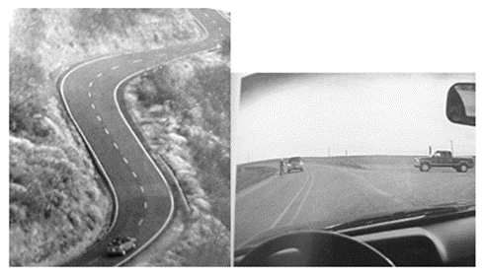

Identify Conditions That Create Line of Sight and/or Path of Travel Restrictions
Supplies: Tally sheet that includes the following: bridges; bushes close to the road; guardrails; newly paved roads; crowned roads; gravel roads; objects close to road; potholes in road; narrow lanes; sharp curves; no shoulders; and broken pavement.
Instructions:
This activity can be used for classroom and BTW.
Divide the class into groups of five.
Have students identify an example of the locations on the Tally Sheet.

Answer the following questions:
1. Which locations have line-of-sight restrictions?
2. What causes the restriction?
3. Which locations require reduced speed and why?
Activity can also be used for BTW:
Observer students identify the above characteristics to the instructor and/or in notebook.
Note the street or road name where the characteristic appears.
Check to see if the driver responds appropriately, or do they notice at all.
Driver can use commentary driving to demonstrate they recognize the above and respond with appropriate driving maneuvers.

